***Programming Fundamentals***

***Fall 2022, Dr. Farooque Hassan Kumbhar***

***Arrays, Strings, Loops, etc.***

1. Let us assume that you have an array of float type with size X (X is the last two digits of your ID). User enters members of this array. Now, you are required to perform all the following options.
2. Find largest element in that array and print
3. Find smallest element in that array and print
4. Calculate SUM of the array
5. Calculate Product of the array
6. Solve matrix where A and B are user entered values.

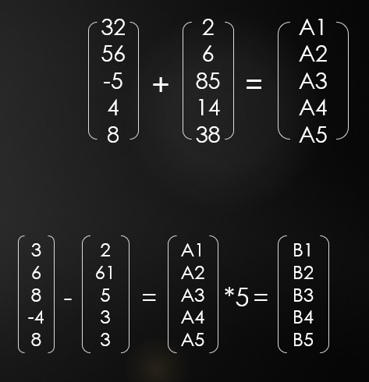

***Questions from QUIZ 2:***

1. A courier company wants to keep track of all parcels, each having an ID, a source location (a, b, c, d), a destination (a, b, c, d), weight in KGs, and status [0. Pending, 1. Delivered, 2. Not Delievered]. Write a program that repeatedly asks the user to create a new parcel (‘c’), or to check the status(‘s’). If create a parcel, then ask for all information and print it. Do make sure that the source and destination are not the same for a parcel. If check the status, then print the total number of parcels so far, the source location of the heaviest parcel, and the status of the lightest parcel. a,b,c,d are digits in your ID.
2. Habib bank has X branches and each branch has Y customers. Write a program that creates accounts and enters customer information for each customer and each branch. Do print the customer information which includes branch#, ID, age, balance. After all customer information entries, do print ID of the youngest customer, age of the customer with highest balance and branch# with highest total balance. X = first two digits, Y = last two digits of your ID
3. Write a program that repeatedly asks user about creating new accounts for a bank. Every time user can respond in three ways, Y, N or E. If Y, then input IDs, initial balance and validity in days. If N, then print a message “I will ask again”, and again ask for user preference. If E, then exit the repetition. Before program ends, you are required to print all ID, all balances and their validity in a tabular form. At the end of the table, do print total IDs count, total balance, and minimum validity.
4. A hybrid vehicle needs a program that keeps track of the fuel usage and battery usage. This program runs indefinitely and stores information for all travels. In each travel, the program asks about KM driven under 40 KM/h speeds, KM driven over 40 KM/h speed. Assuming that the vehicle uses 1 L for 15 KM and 1 full battery for 30 KM. Calculate the total cost of all travels if 1 L is bought at the rate of XYZ rupees (XYZ is first three digits of your ID). Every time user enters the details, print total KM driven so far, the total cost of the fuel and number of times battery completely used.